Finally: Discover a Proven Process...

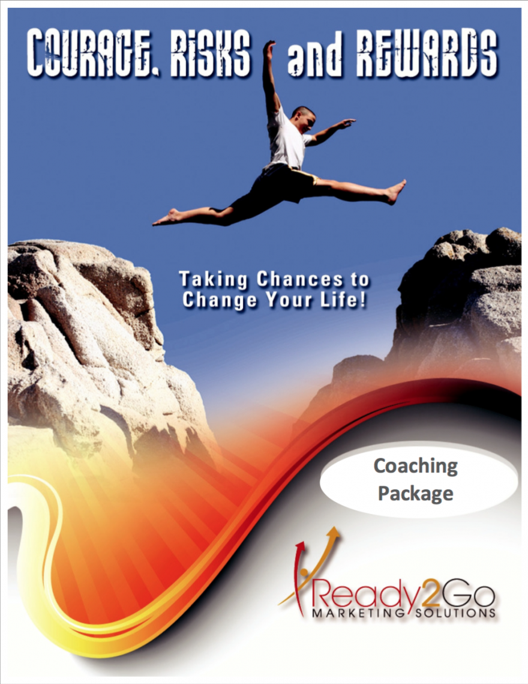
... To Access Your Courage, Take Healthy Chances, and Reap Exciting Rewards, So You Can Stop Feeling Stuck, Defeated, and Frustrated!
- You know that in order to create change, you have to take risks. But taking risks often stops you in your tracks, because you have a lot to lose.
- Although you seek change, you're afraid of making a big mistake and not being able to recover from it.
- Your life is “safe,” as it is. But right now, "safe" feels synonymous with “boring and mediocre”! You want your life to be GREAT… and you know you need to take some chances in order for that to happen, but you're not sure which chances to take.
- Your gut is telling you it's time to take action – even if that means moving beyond your comfort zone – but your mind is telling you, "That's just crazy!"
- You're afraid taking a risk might result in failure, embarrassment, rejection, or loss … so you stick with what you know, even though you believe you could be happier and more fulfilled.

If any of these resonate with you, then I have good news: you're in the right place, and you're not alone.
Receive your free copy today and learn how to access the courage to take healthy risks. And when you do, you'll reap the rewards in terms of fulfillment and satisfaction!
INSERT OPT-IN FORM HERE

